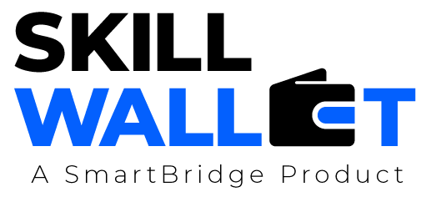

Communication

Date | 13 July2026
Team ID | XXXXXX
Project Name | XXXXXX
Maximum Marks | 1 Mark

Communication Plan:
Effective communication is essential for a successful project demonstration. This document outlines the communication strategy used within the team and with stakeholders throughout the project lifecycle, including how updates, issues, and feedback were managed.

S.No | Communication Type | Frequency | Channel / Tool | Participants | Purpose
1 | Team Standup | Daily | Google Meet / WhatsApp | Hemalatha | Discuss daily tasks, progress, and blockers.
2 | Progress Update | Weekly | Google Meet / Microsoft Teams | Hemalatha | Review completed work, assign new tasks, and track project milestones.
3 | Issue / Bug Discussion | As Needed | WhatsApp / GitHub / VS Code Live Share | Hemalatha | Resolve coding issues, API errors, and integration problems.
4 | Stakeholder Review | Bi-Weekly | Google Meet | Hemalatha | Demonstrate project progress and collect feedback for improvements.
5 | Final Demo Rehearsal | Once | Google Meet | Hemalatha | Practice the final project presentation and verify application functionality.

Communication Challenges & Resolutions:
S.No | Challenge Faced | Resolution / Action Taken
1 | Integration issues between Streamlit frontend and FastAPI backend. | Conducted debugging sessions, verified API endpoints, and resolved communication errors.
2 | AI model loading delays and dependency installation issues. | Optimized model loading, installed required libraries correctly, and tested the environment.
3 | Coordinating tasks and maintaining documentation among team members. | s cheduled regular meetings, assigned responsibilities, and used shared documents for collaboration.

